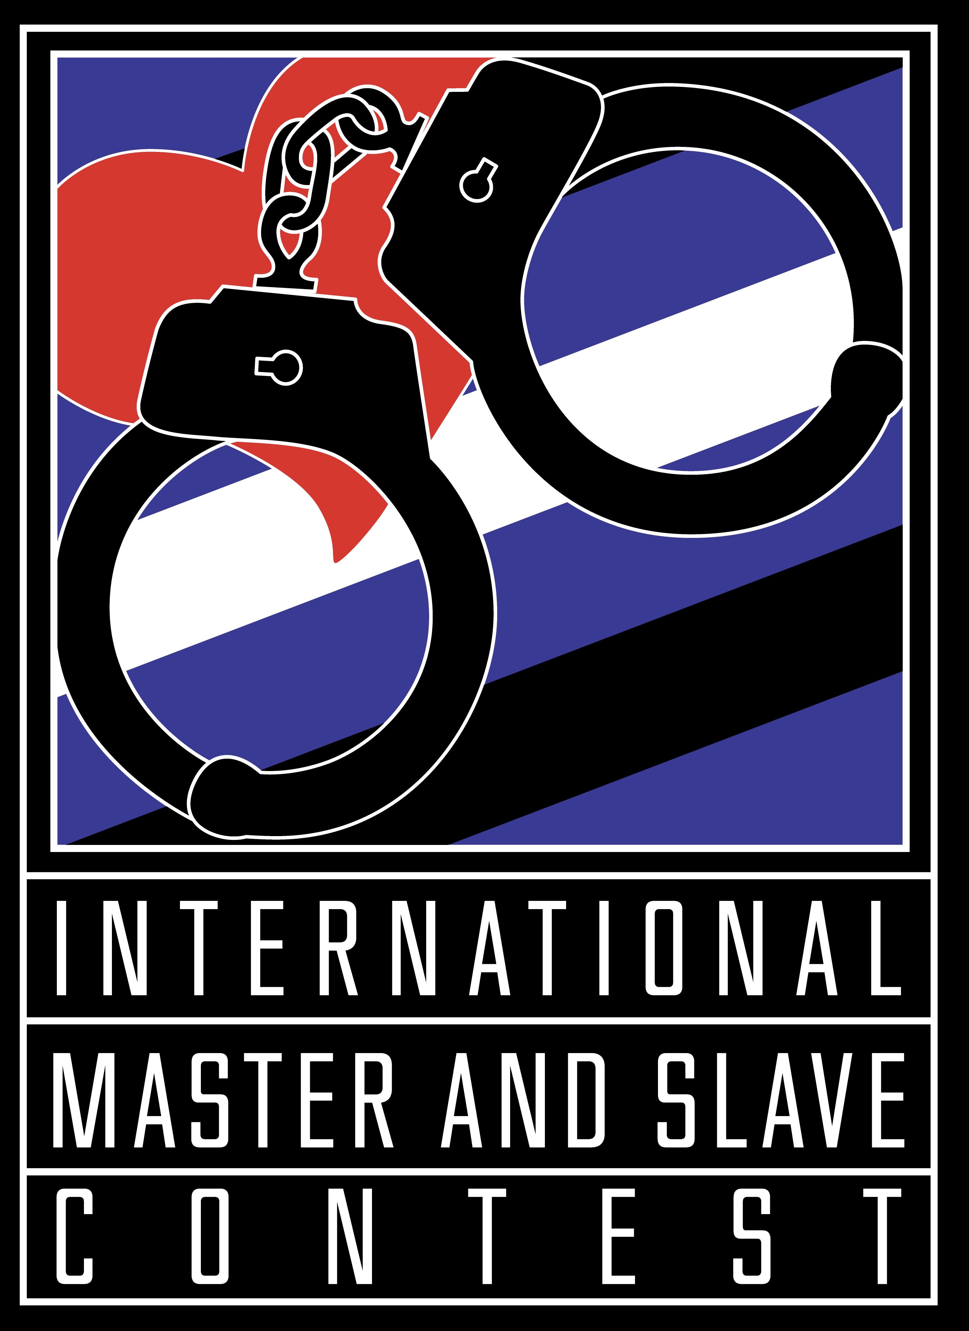
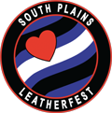
International Petition
International Master slave Contest
Owned and Produced by South Plains Leatherfest

(Last Updated: 6/8/2025)

Basic Philosophy for the International Master/slave Contest and Titles

The International Master/slave Contest (“International”) is owned and produced by Tomo (“Owner/Producer”). The Owner/Producer is committed to providing the M/s and Leather/BDSM communities with an International Master and an International slave who will represent the Master/slave community and lifestyle with integrity and competence. The holders of the International Master and International slave titles will be spokespersons for the Master/slave community, and as such, one of the most important attributes of the titleholders should be the ability to clearly and effectively communicate what it means to them to live and identify as Master/slave or Owner/property.

Eligibility of International Contestant Pairs to Compete at International Master/slave

International invites and encourages contestant pairs from outside of the United States (“international contestant pairs”) pursuant to the following rules and policies:

- The decision to accept any international contestant pair by Petition to compete at the International Master/slave Contest (“International”) in any given year is completely within the discretion and control of the Owner/Producer of International.

- Both members of an international contestant pair must be 21 years of age or older at the time the International Contestant Petition to Compete (“Petition”) is submitted.

- An international contestant pair must have been in a self-identified Master/slave or Owner/property relationship with each other for at least one 1 year prior to petitioning to compete at International and individually have been in the Leather and/or M/s Community for a minimum of 5 years.

- Becoming an International M/s Contest contestant pair is a two-step process:

  - The international contestant pair must submit an International Contestant Petition to Compete (“Petition”) no later than October 1 prior to International. (For example, an international contestant pair wishing to compete at International 2025 would need to submit a Petition no later than October 1, 2024.) International contestant pairs who petition to compete will be notified of International’s decision on their Petitions no later than October 15. In a given year, an International pair may be accepted prior to the October 1st deadline. Only one international pair will be selected each year.

  - If an international contestant pair’s Petition is accepted, the pair will be required to follow the same International rules as a Regional contestant pair, including submitting the formal IM/s Contestant Application. All contestants will be judged according to the IM/s Judges’ Handbook and will be subject to the rules and requirements found in the Judges’ Handbook, the International Master/slave Contest Application, the International Master/slave Contest Handbook and the International Master/slave Contest Regional Handbook. These documents are available at the South Plains website (www.southplainsleatherfest.com).

- If an international contestant pair lives in Canada or Mexico, the pair has the option of either: petitioning International directly to compete at International or; competing in and winning an authorized U.S. Regional contest.

Canada:
Contestants who live in Canada may either petition International directly to compete in the International M/s Contest or if they desire support from a U.S. Regional Contest and Organization, they may compete in and win an authorized U.S. Regional contest.

- British Columbia and Alberta may choose to run in the IMs Northwest Regional contest.
- Saskatchewan, Manitoba, north of Manitoba, Yukon and the Territories may choose to run in the IMs Midwest Regional contest.
- Ontario and east of Ontario may choose to run in the IMs Northeast Regional contest.

Mexico:
Contestants who live in Mexico may either petition International directly to compete in the International M/s Contest or if they desire support from a U.S. Regional Contest and Organization, they may compete in and win the Southwest Regional contest.

- An international contestant pair is not required to go through a regional contest, other contest, or other selection process in order to submit a Petition to Compete at International.

- An international contestant pair must agree that during the time period between the date they submit their petition to International and the date of the International Master/slave Contest, they will not engage in interviews with or appear in “vanilla” mainstream media (whether print, television, film, radio or internet based) without the express written consent of the Owner/Producer of the International Master/slave Contest.

- If the Petition of an international contestant pair is not accepted by International, that pair may re-petition International for the opportunity to compete in a future year. An international contestant pair, either as individuals or as a pair, may not petition to compete at International more than two (2) times.

- If the Petition of an international contestant pair is accepted by International but the pair does not win at International, the pair may re-petition International for the opportunity to compete in a future year. An international contestant pair, either as individuals or as a pair, may not petition to compete at International more than two (2) times.

- If an international contestant pair competes and wins the International contest, that pair, either as individuals and/or as a pair, is not eligible to petition or to compete at International in any subsequent year.

- It will be the responsibility of an international contestant pair competing at International to obtain all travel documents, visas, clearances, etc. needed in order to enter the United States. Because of the privacy sensitivities and issues that still impact the M/s community in the U.S., an international contestant pair should not highlight the International contest or South Plains Leatherfest as the reason for entering the country.

- The official language of the International contest is English. If a contestant or contestant pair believes they need an interpreter to effectively compete at International, they may bring one at their own expense. The interpreter will be given a basic ticket to South Plains Leatherfest.

- Prior to submitting a Petition, an international contestant pair should carefully read the IM/s Judges’ Handbook, the IM/s Handbook and the formal IM/s Contestant Application, all of which are available at the South Plains website (www.southplainsleatherfest.com).

- If an international contestant pair wins International, the pair will be expected to meet the requirements for the title as stated in the Contestant Handbook. The titleholders are required to attend a minimum number of events each year; these events do not have to be in the United States.

Petition to Compete at
The International Master slave Contest

Deadline: October 1st.

Please return an electronic copy of the completed Petition to Tomo.SPLF@gmail.com.

The year of contest you are petitioning to compete in:

Legal Names:

Scene Names (if any):

FetLife, Facebook or other BDSM Social Networking Site Names (if any):

Address:

City: State/Province:

Country: ZIP/Postal Code:

Phone:

Email(s):

Club or group affiliations:

Time in current Master/slave relationship:

Individual time in the M/s, Leather, Kink Communities:

Please describe your Master/slave relationship. (Use as much space as needed.)

Has either the Master or the slave ever been convicted of a felony in the U.S. or any criminal act in another country that would be the equivalent of a felony crime in the U.S.? [Please note: The decision as to whether a felony conviction or its equivalent will disqualify a contestant pair from competing for the IM/s Title is solely within the discretion and judgment of the Owner of the IM/s Title System.]
Yes _______ (Please provide details below.)
No _______

Has either the Master or the slave ever been accused of a consent violation, abusive behavior or any other violation in the community? [Please note: The decision as to whether an accusation of a community violation will disqualify a contestant pair from competing for the IM/s Title is solely within the discretion and judgment of the Owner of the IM/s Title System.]
Yes _______ (Please provide details below.)
No _______

Master/slave, BDSM/Leather events attended in the past year – please provide name of the event, location, a brief description of the event and approximate number of attendees. (Use as much space as needed.)

How did you find out about the International Master/slave Contest? (Use as much space as needed.)

Why would you like the opportunity to run for the International Master and slave title? (Use as much space as needed.)

Describe the Master/slave community in your home country (is it well developed, newly forming, etc.) and how your participation as contestants in the International Master/slave Contest would benefit your home community. (Use as much space as needed.)

If you ran for and won the International Master and slave title, how would you as titleholders living outside of the United States maintain a presence at U.S. based events, including the IM/s Regional contests and events as well as events outside of the United States? (Use as much space as needed.)

Any additional information you would like the Owner/Producer of IM/s to know? (Use as much space as needed.)

DISCLAIMER AND RELEASE OF LIABILITY: In consideration of the acceptance of our Petition herewith by the Owner and Producer of South Plains Leatherfest and the International Master/slave Title and Contest, by completing this Petition we hereby waive, release and forever discharge South Plains, L.L.C., South Plains Leatherfest, its owners, producers, members, agents, operators, employees, lessors, lessees, parent companies or entities, affiliated companies or entities, representatives or subsidiaries from any and all demands, actions, causes of actions, claims of injury or damage to our persons, property or reputations, costs, damages, expenses, attorney’s fees or penalties of any kind or nature, whether asserted or unasserted, known or unknown, that may arise now or in the future from any cause whatsoever in connection with our participation in and with the International Master/slave Contest and South Plains Leatherfest. We hereby give permission for the use of our scene names in connection with publicity for South Plains Leatherfest and the International Master/slave title and contest. By completing this Petition, we hereby state that we have read and understand the above disclaimer. We further state that each of us is at least 21 years of age.

Electronic Signature of Master/Owner by typing name:

Electronic Signature of slave/property by typing name:

